Process Document of Combustion Work Request
Submitted to:
Kirloskar Oil Engine Limited(KOEL)
Date: 21 September 2020

Document History:

Version | Author | Date | Comments
1.0 | Rohan Indalkar | 21/09/2020

Table of Contents
1. New Work Request Document Creation Steps: 4
2. Work Request Process: 7
3. Process Hold (By Assembly Dept.): 19
4. CRE Assembly Report Creation & Approval: 21
5. CRE Test Report Creation & Approval Process: 25
6. Emission Test Report Creation and Approval Process: 28
7. Swirl Lab Test Report Creation & Approval: 31
8. FIP Calibration Test Report Creation & Approval Process: 35

New Work Request Document Creation Steps:
- Go to browse tab then go to Libraries the go to Work Request library and then in the Folders.
Click Browse Tab Libraries Work Request Folders

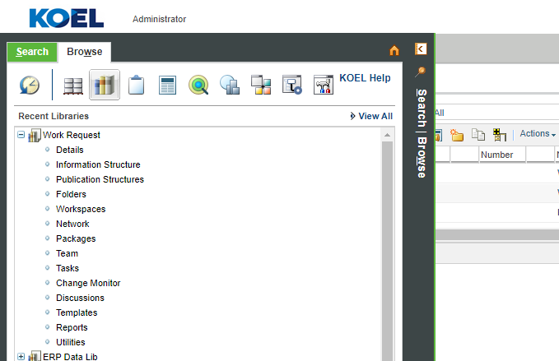

- In folders go to Work Request COMBUSTION folder.
Folders Work Request COMBUSTION
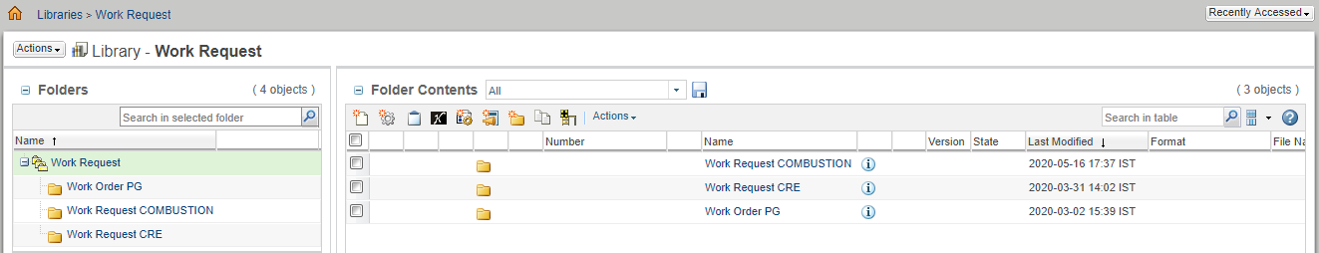

- Now click on New Document to create new Work Request document.
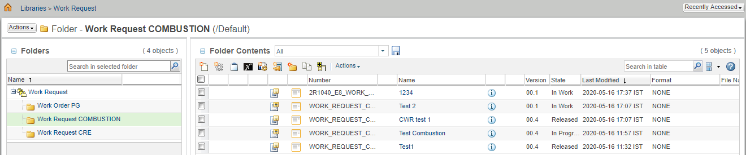

- Then click on the select type and select type as COMBUSTION Work Request.
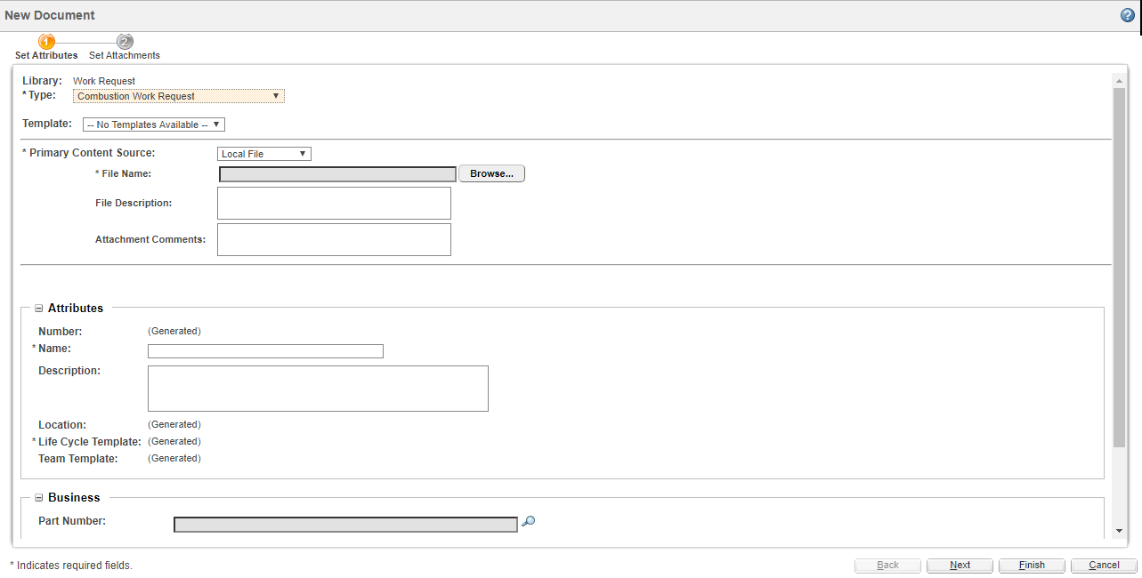

- Attach source file to Work Request through browse button


- Fill the mandatory details and click on Next button.
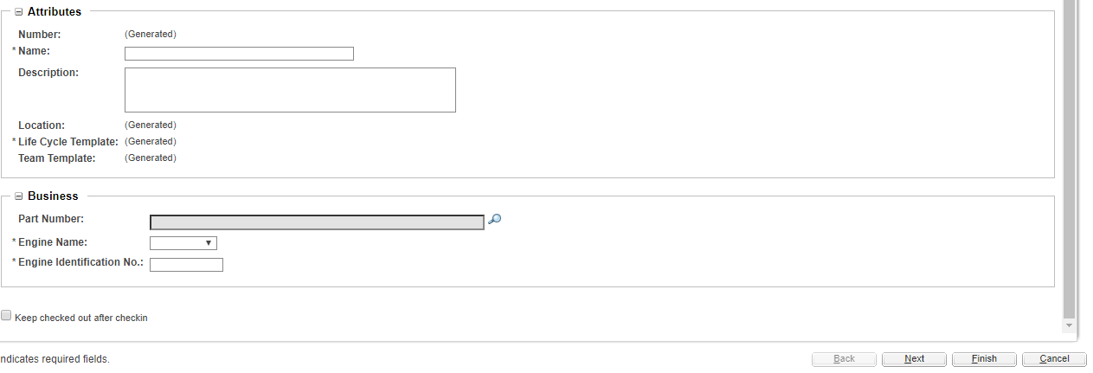

- Click on search icon to select part no. (If required) below window appears. Enter valid details to search part no. & select Design view of the required part.
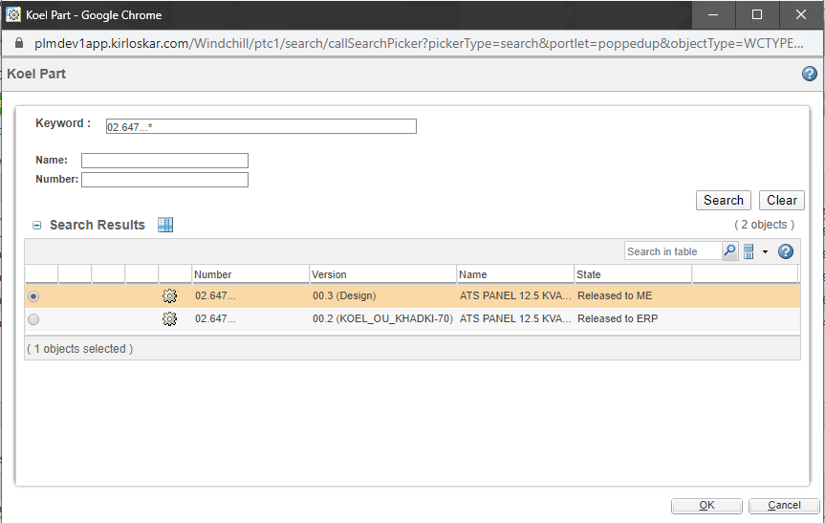

- Attach if there are any extra attachments then click on the finish button.

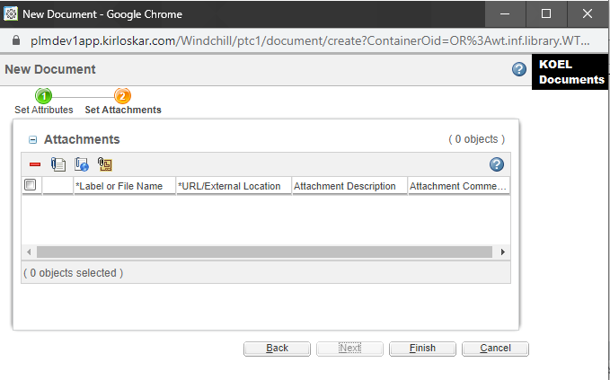

Work Request Process:
- Once document is created successfully it appears as follows.
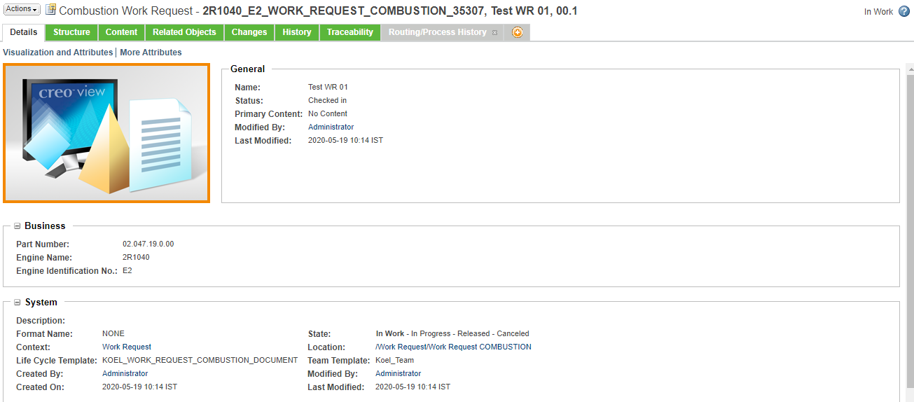
- Select Routing/Process History tab for viewing / completion of tasks.
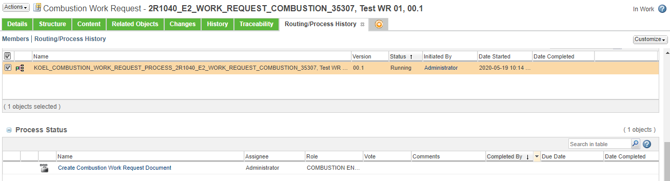

- First task is to Create Combustion Work Request document which is assigned to COMBUSTION ENGINEER. As per the given instructions on task page user completes the task.
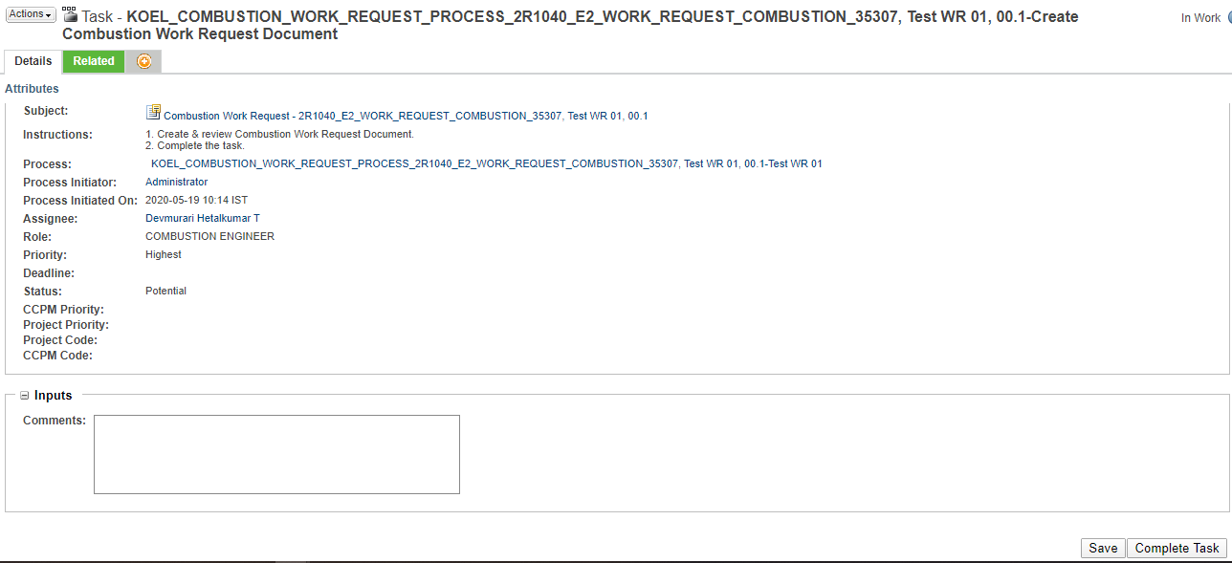

- Next task is again of COMBUSTION ENGINEER to Assign work request to department.
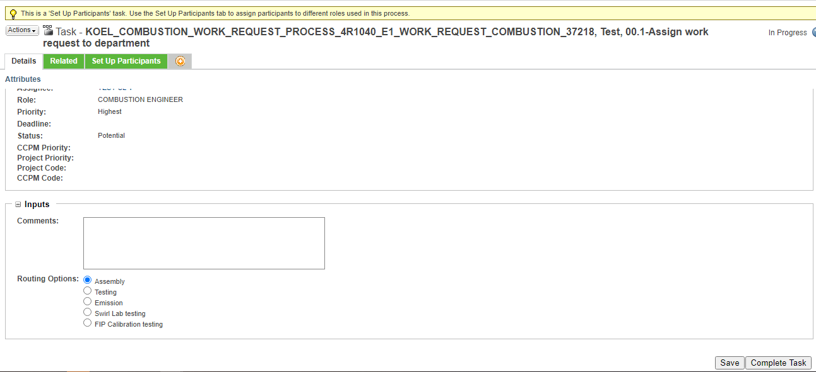

  - User has to select a participant from assembly department if he wishes to assign further process to assembly department as shown below.
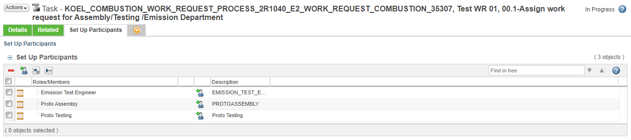
  - After selecting Add participant button shown above below tab appears in which a participant from desired department department can be selected as follows. ( Proto Assembly is selected for demo purpose )
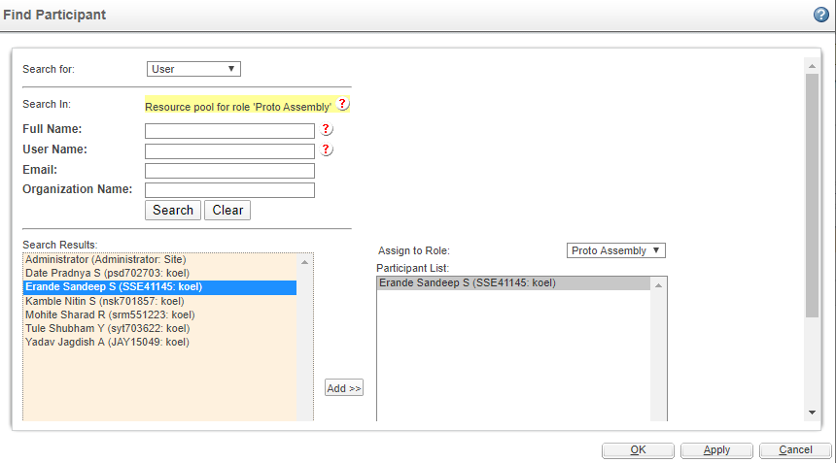

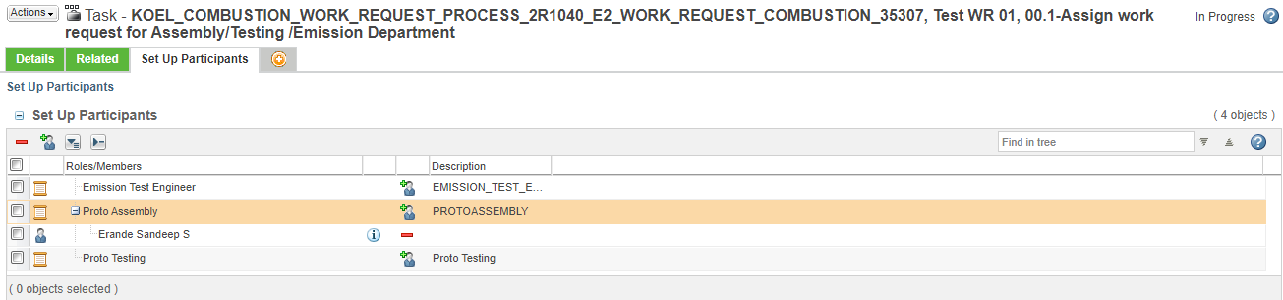

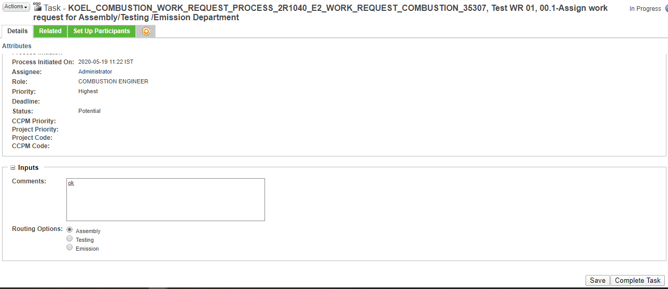

- Next task Create Assembly report for Combustion work request is assigned to Proto Assembly participant in which user has to create assembly report & get it approved before task completion.
  - Select the link in instruction to create Assembly report.
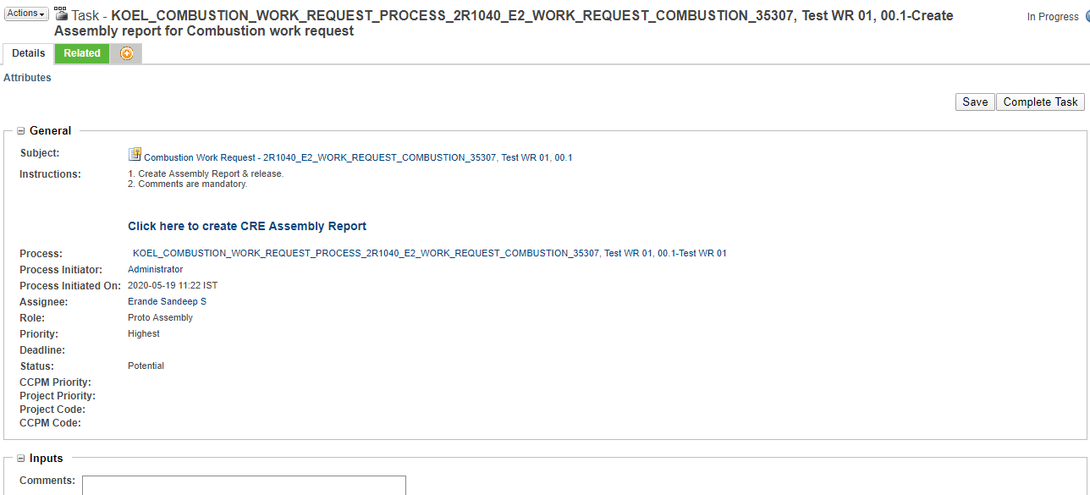

  - After creation of assembly report it has to be individually approved through another approval process set on the document & after approval it gets automatically attached to Work request.
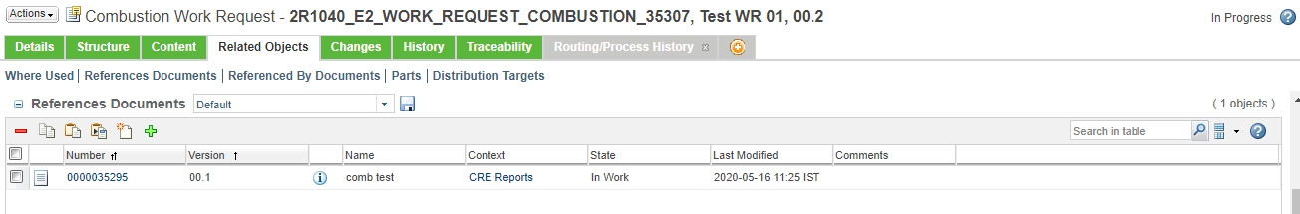

- On completion of above task COMBUSTION ENGINEER is again assigned with Assign work request for Testing/Emission testing Department task. (Any one department can be selected)
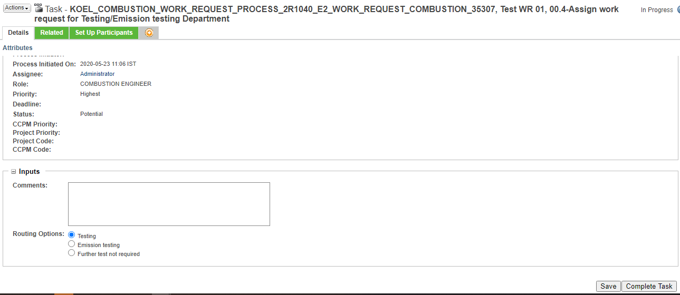
  - On completion of above task Select test Engineer task is assigned to Testing department / Emission testing department head.
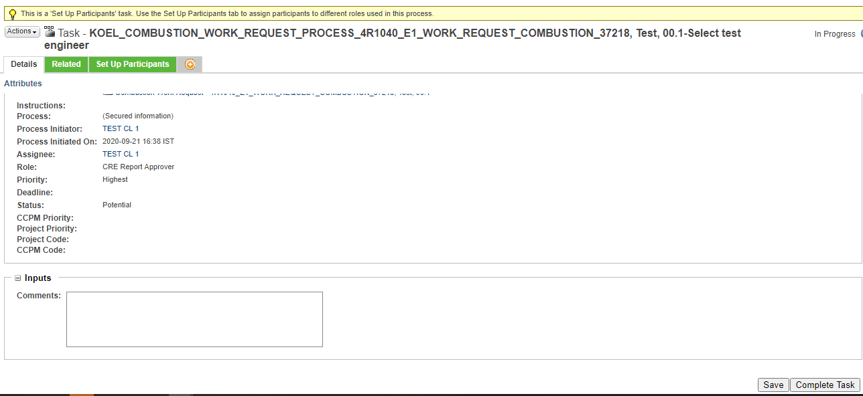

  - User has to select a participant from Proto Testing department / Emission Testing department for further process as shown below.
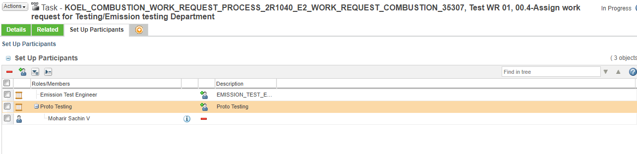

  - After selecting Add participant button shown above below tab appears in which a participant from Proto Testing department can be selected as follows.
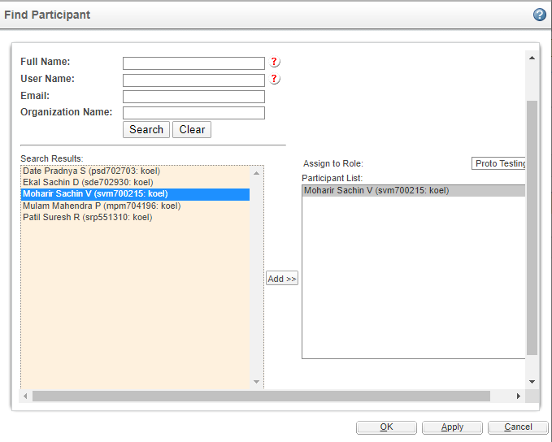

Note:
- On selecting Emission testing on above task next task on attachment & completion of report attachment task by Emission department will be of Close work request which will be assigned to Combustion Engineer.

- On selecting further test not required Close work request task will be assigned to Combustion Engineer

- Next task Create Test report for Combustion work request is assigned to Proto Testing participant in which user has to create testing report & get it approved if possible before task completion.
  - Select the link in instruction to create Test report.
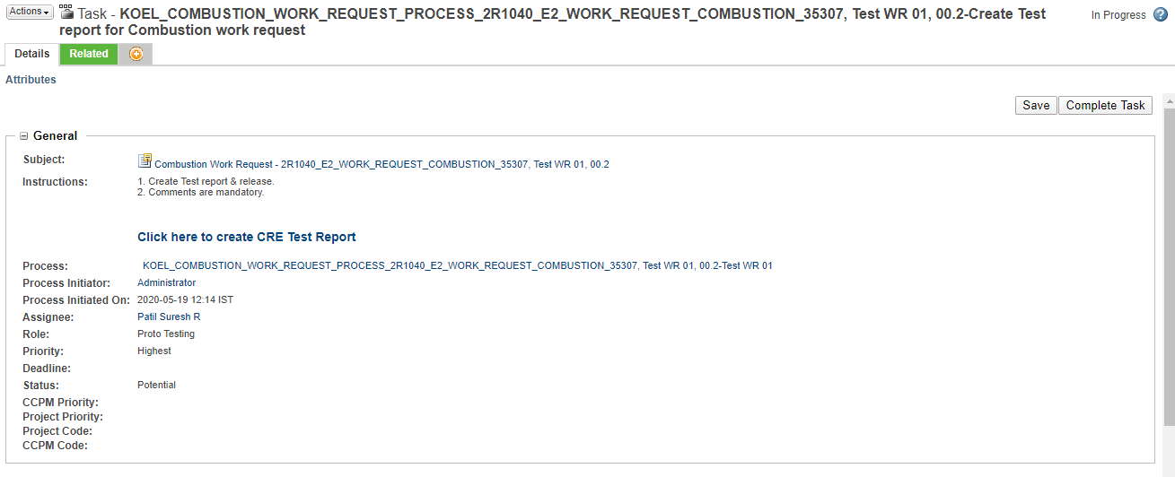
  - After creation of testing report it has to be individually approved through another approval process set on the document & after approval it gets automatically attached to Work request.
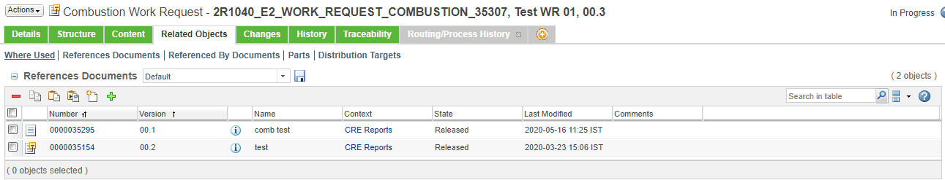

- On completion of above task COMBUSTION ENGINEER is again assigned with Assign work request for Emission testing Department task.
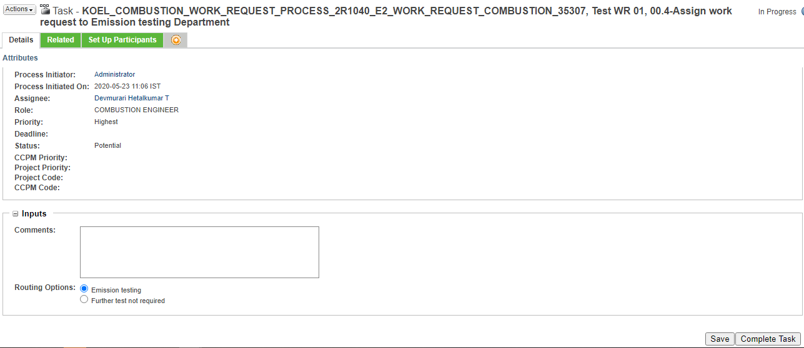

  - User has to select a participant from Emission Testing department for further process as shown below.
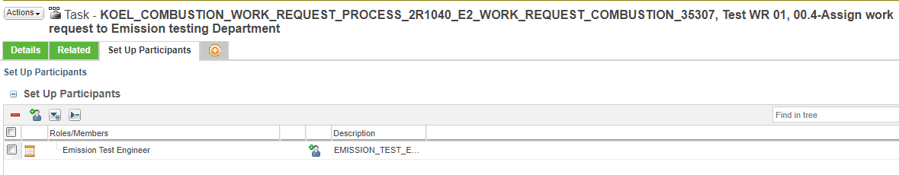

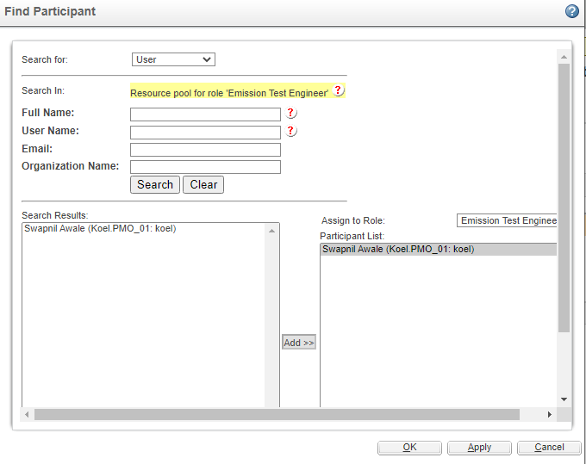

  - Complete the task as shown below.

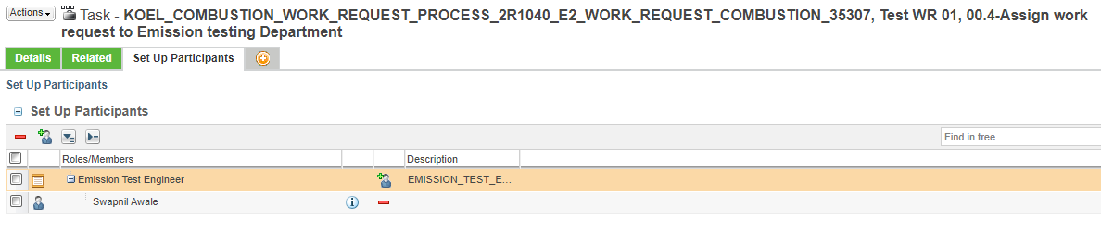

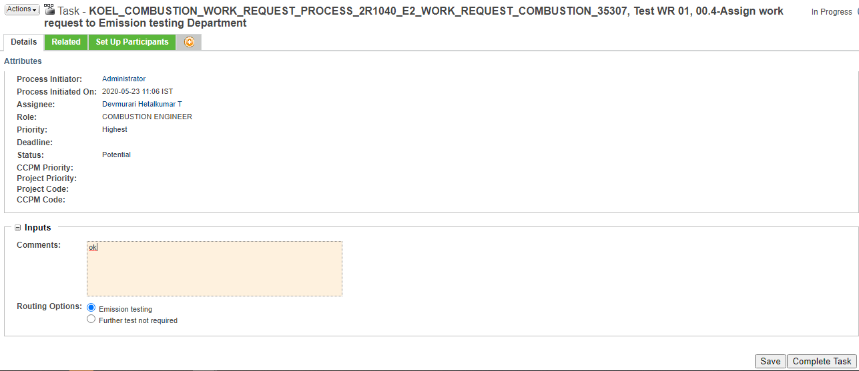

- Next task Create Emission report for Combustion work request is assigned to Emission Test Engineer.
  - Select the link in instruction to Emission Test Report.
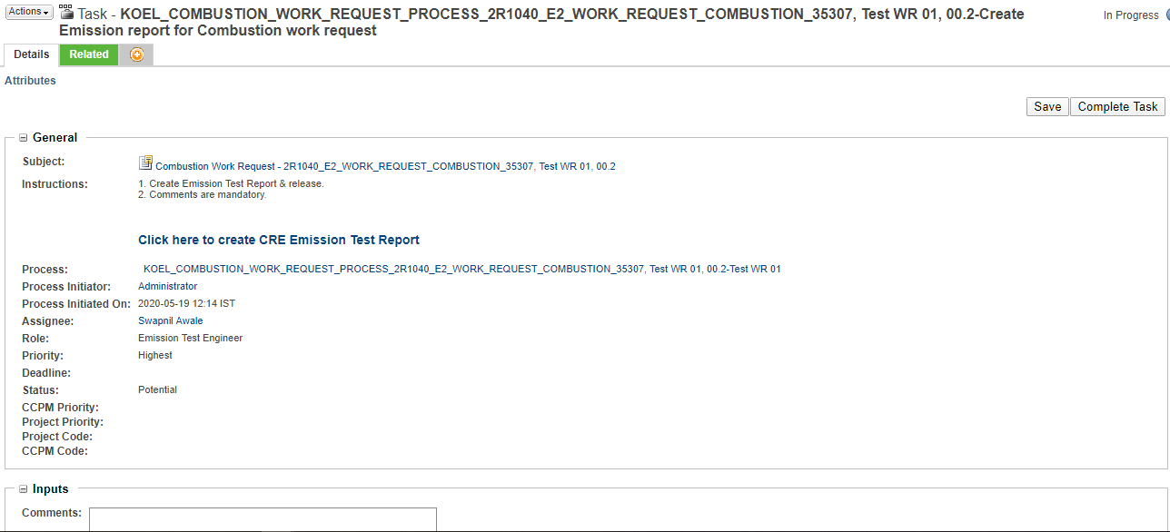
  - After creation of testing report it has to be individually approved through its approval process set on the document & after approval it gets automatically attached to Work request.
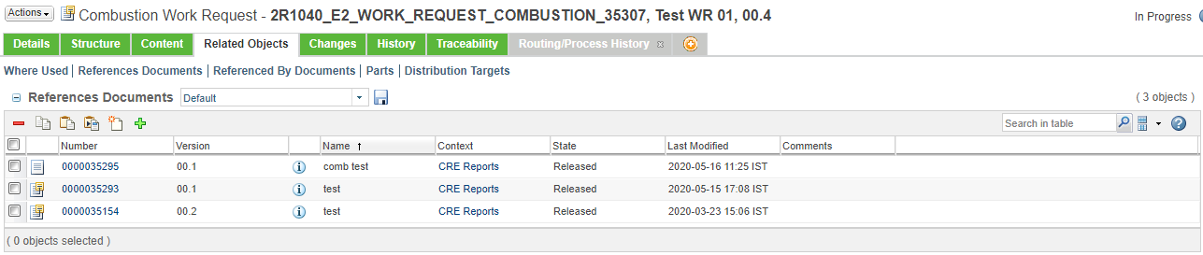

- If Work request creator selects Swirl Lab testing option on Assign work request to department, Attach Swirl Lab Testing Report is assigned to Combustion Engineer.
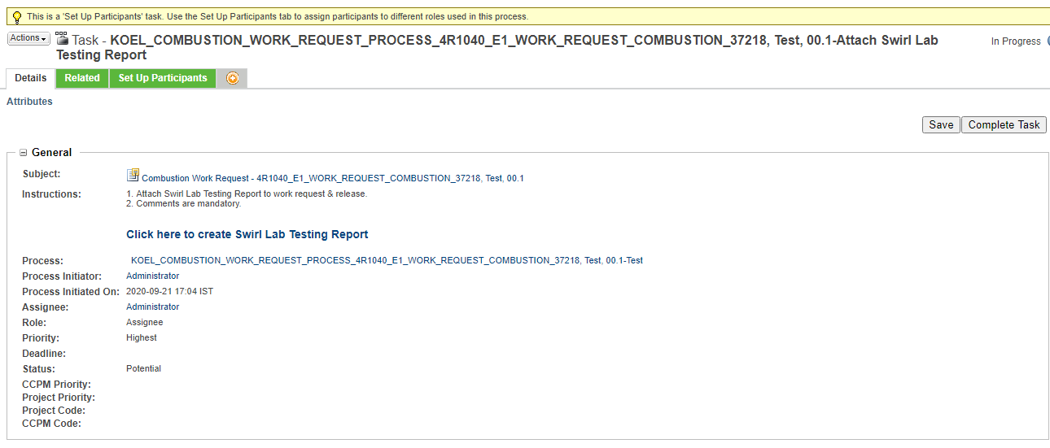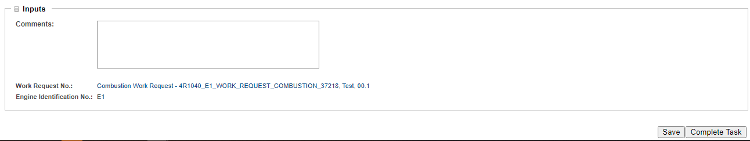

- Note: Similarly if FIP Calibration department is selected at the time of work request creation, user gets task for creating & attaching FIP Calibration test report.

- User has to select the document creation link to create the related document.


- After creation of Swirl Lab Testing report it has to be individually approved through another approval process set on the document & after approval it gets automatically attached to Work request.
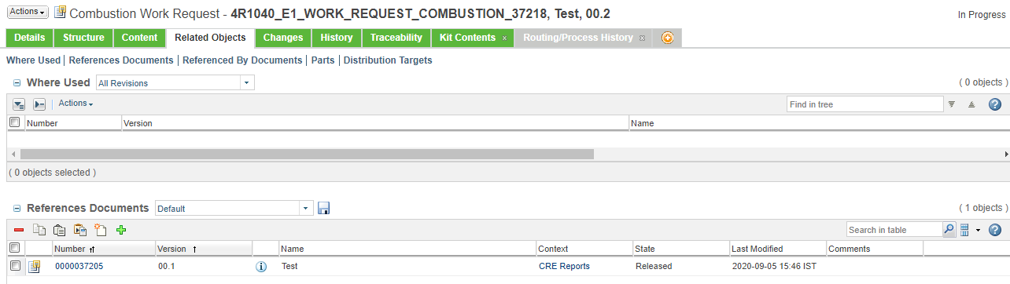

- Next task Close work order is assigned to COMBUSTION ENGINEER.

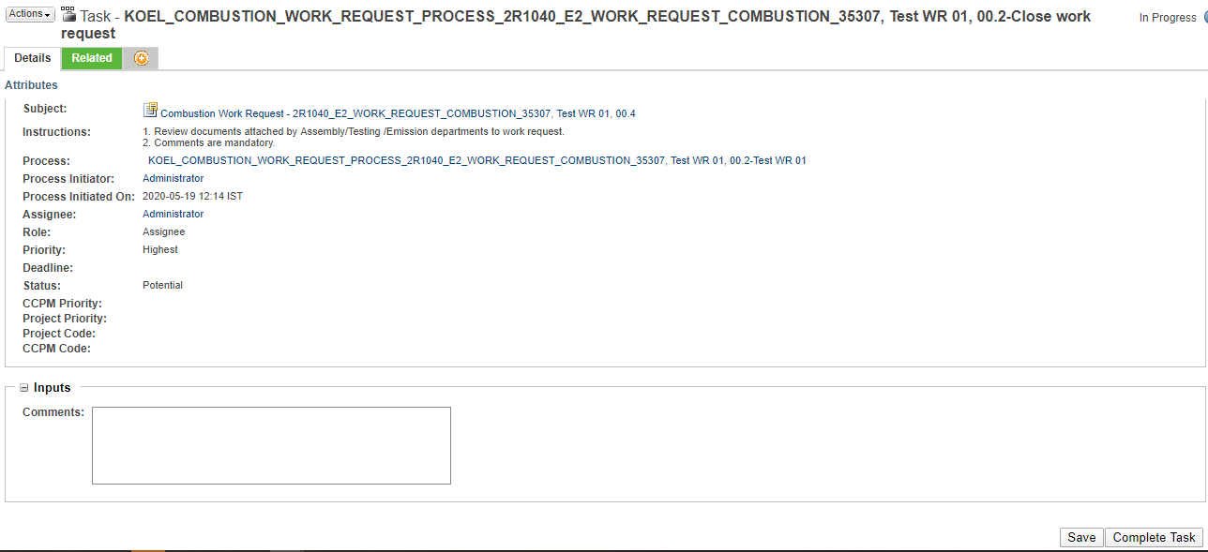

- On completion of all task Work Request state changes to Released & it gets attached to related App code / Part no.

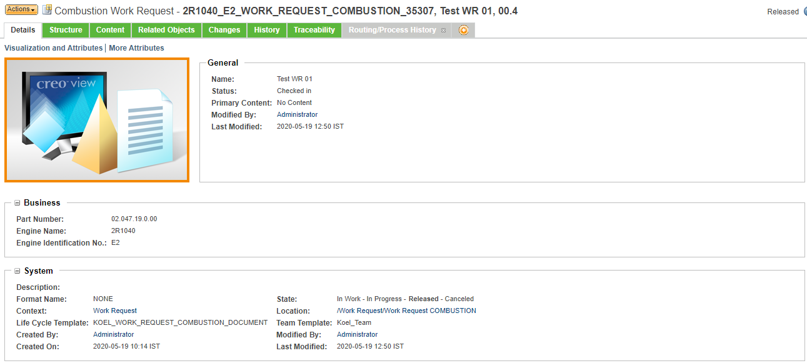

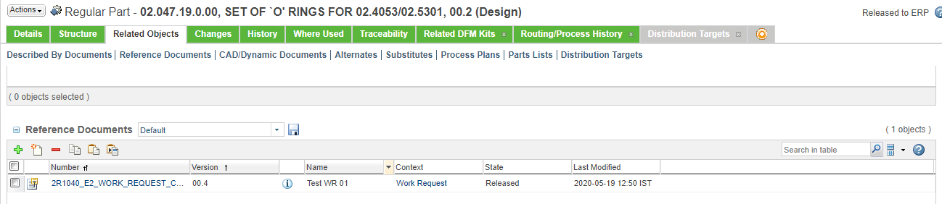

Note:
- If Part no. is not given process is completed directly.
- On selecting one department in Assign work request task the next assignment task will have options to route work request to other two remaining departments. ( If Testing department is selected first, next work request assignment task will have option to route work request to Assembly & Emission department )
- If further test not required option is selected in second work request assignment task process ends after that task.

Process Hold (By Assembly Dept.):
- For holding the process Proto assembly member has the option to hold the process on Create Assembly report for Combustion work request.
Select Hold Enter comments Complete task

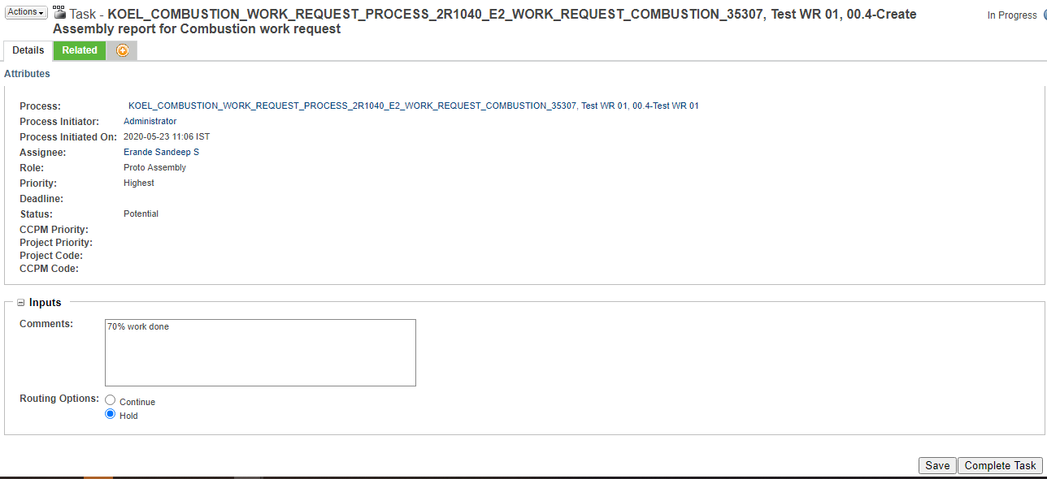

- On completing above task Work request state changes to On Hold & next task Reopen hold process is assigned to Proto Assembly user who has held the process previously.
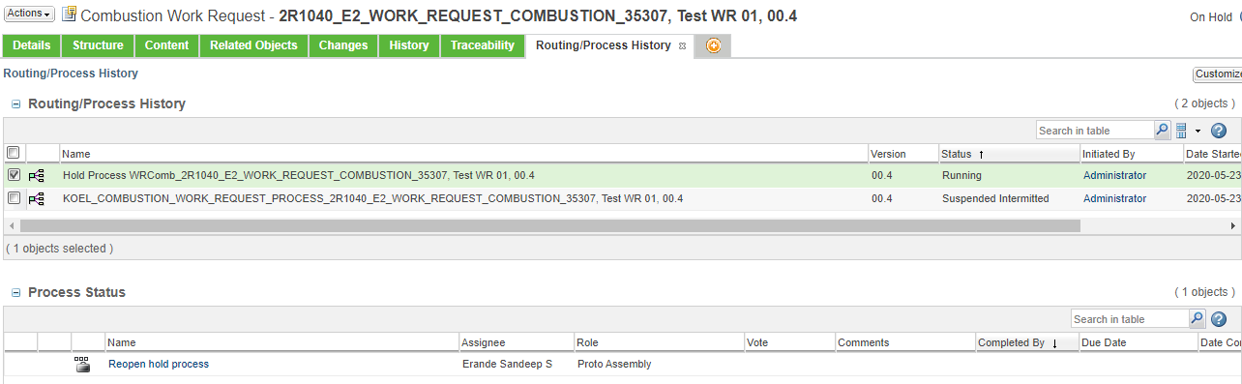

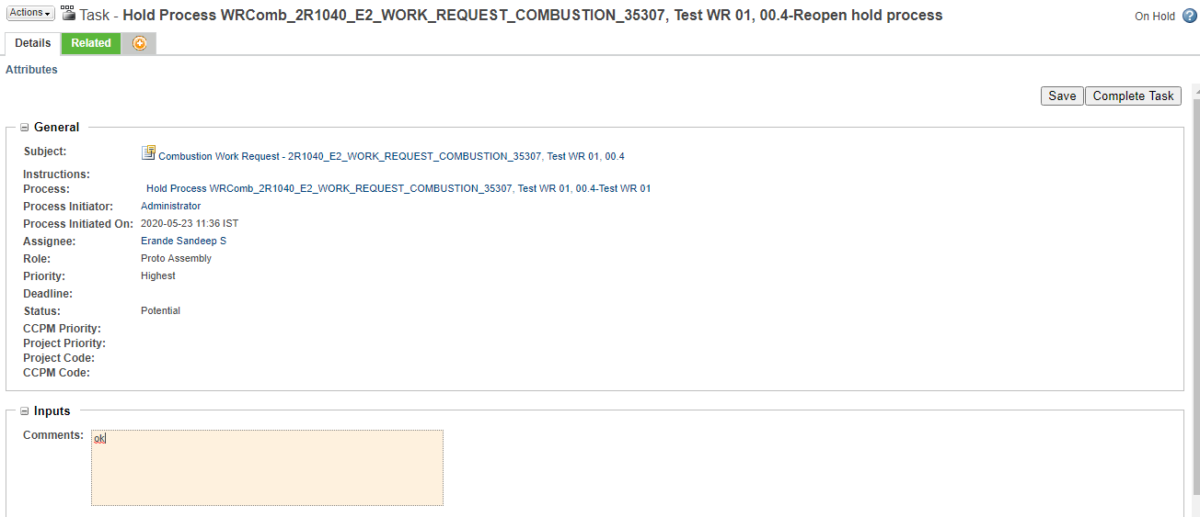

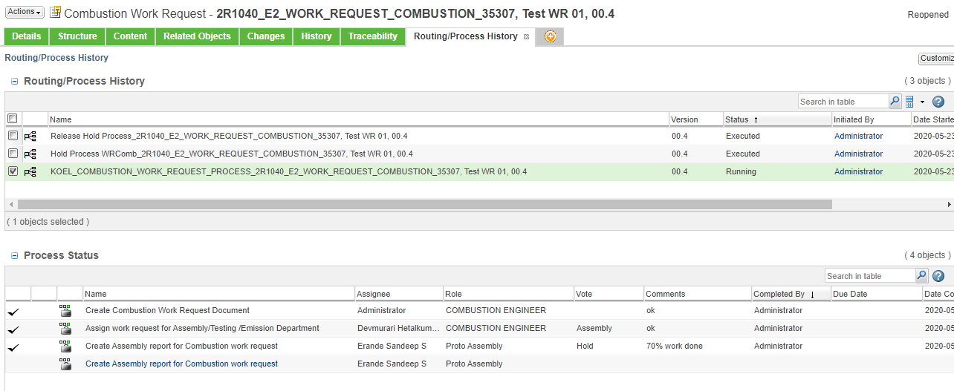
3. On completion of above task Work request state changes to Reopened & Create Assembly report for Combustion work request is reopened again.

CRE Assembly Report Creation & Approval:
- Report can be created by going to browse tab then go to Libraries the go to CRE Reports library and then in the Folders or through the link given on task page.
Click Browse Tab Libraries CRE Reports Folders

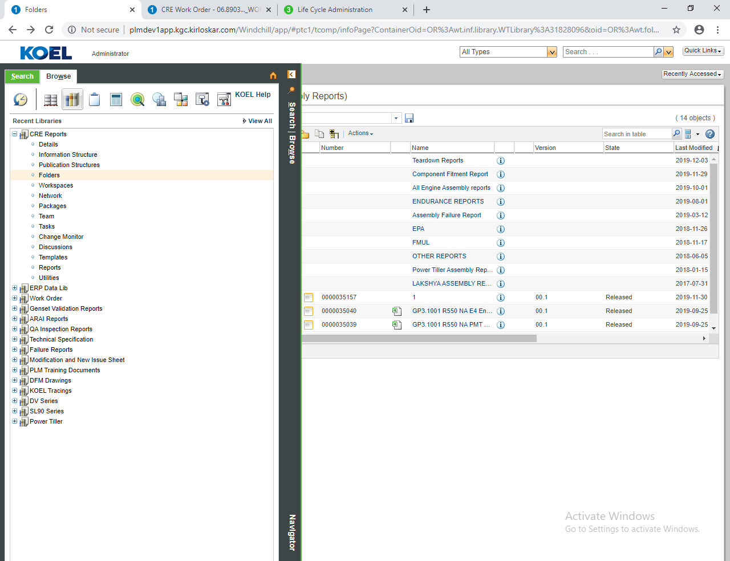

- In folders go to CRE Assembly Reports folder
Folders CRE Assembly Reports
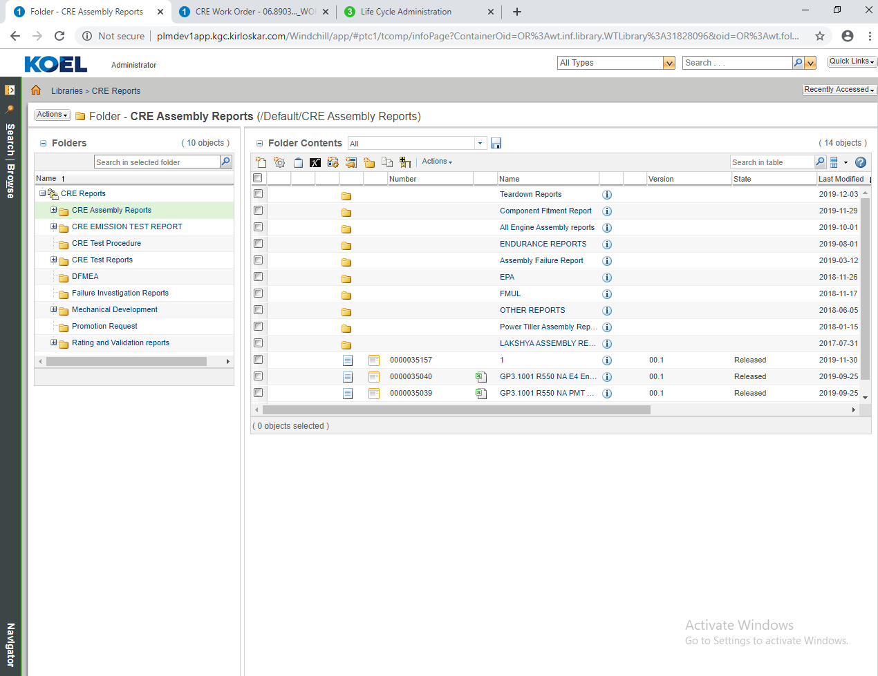

- Now click on the new document to create new CRE Assembly report.


- Select type CRE Assembly Report from select type.
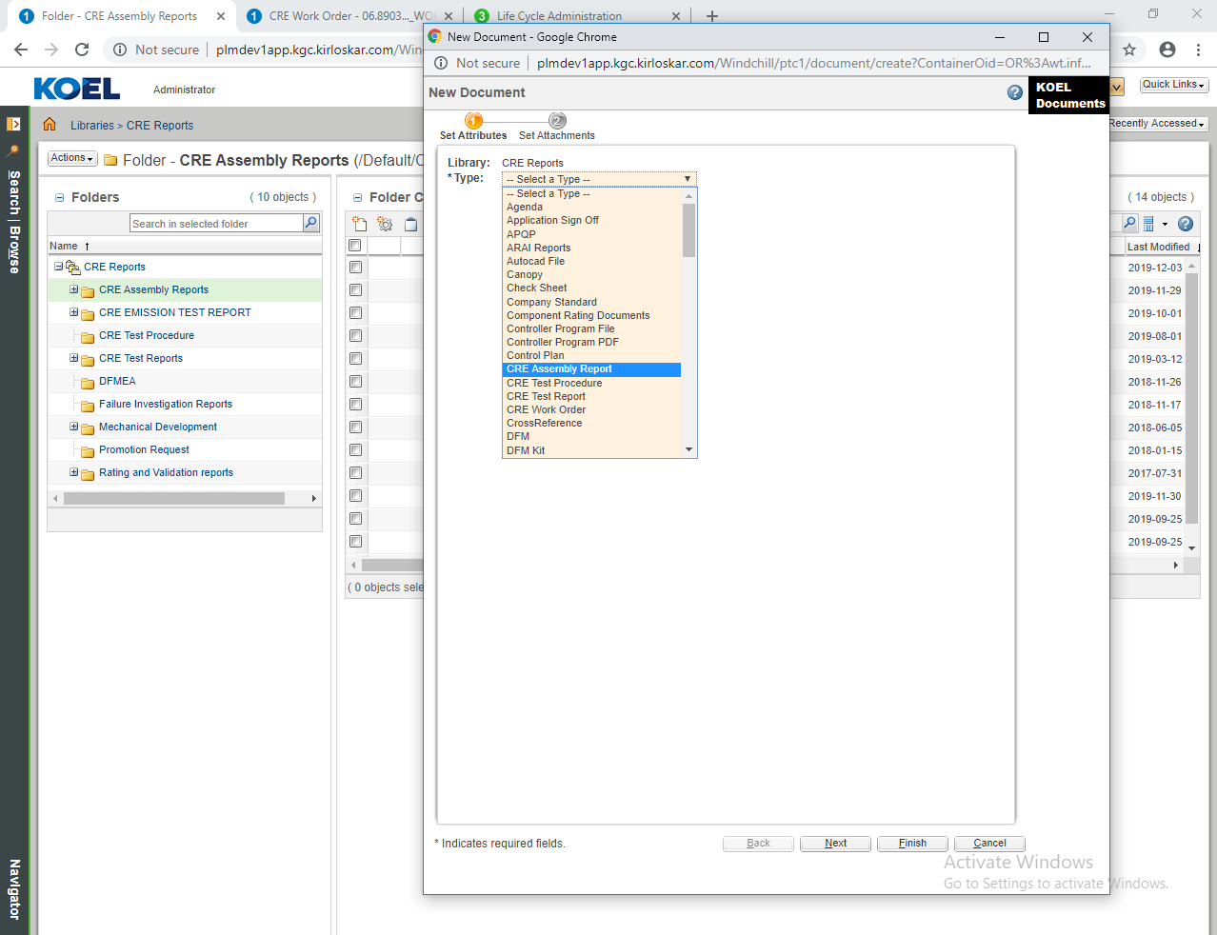

- Attach source file to CRE assembly report through browse button.
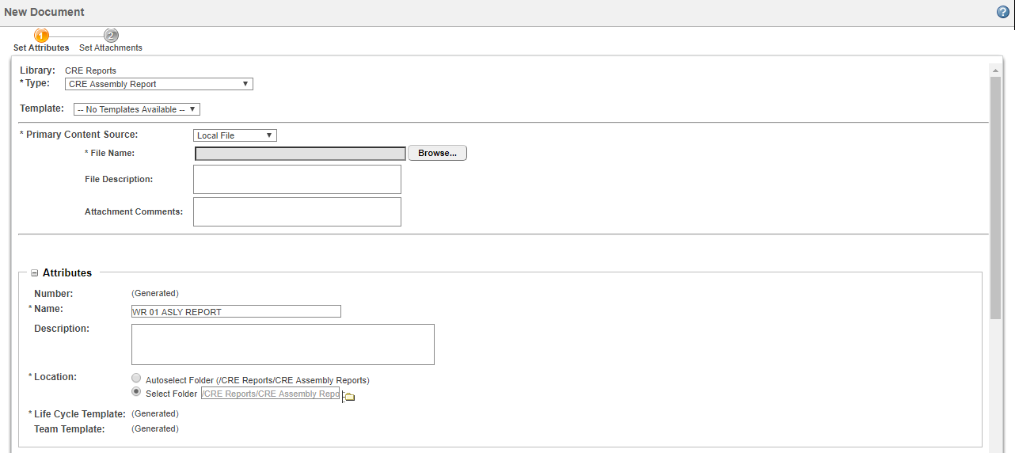

- Fill all the mandatory fields and click on finish.
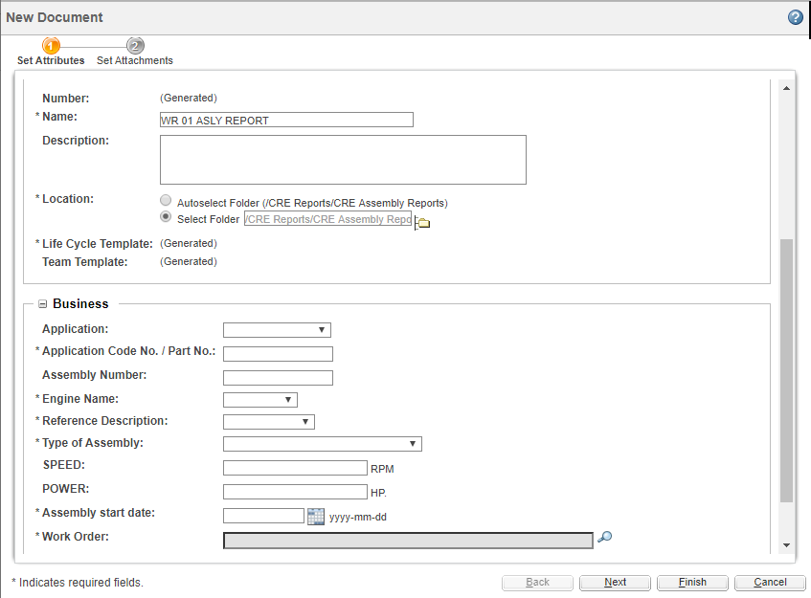

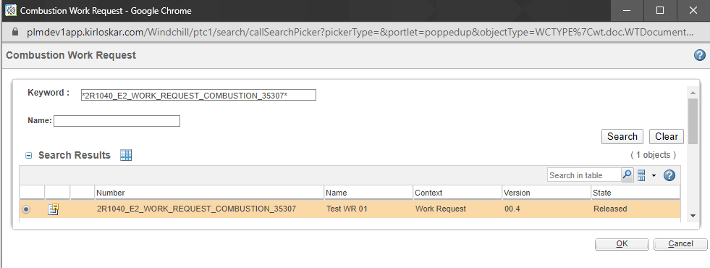

- On creation of the document approval task is assigned to CRE Assembly Report Reviewer. Approver can Approve / Rework document for changes.
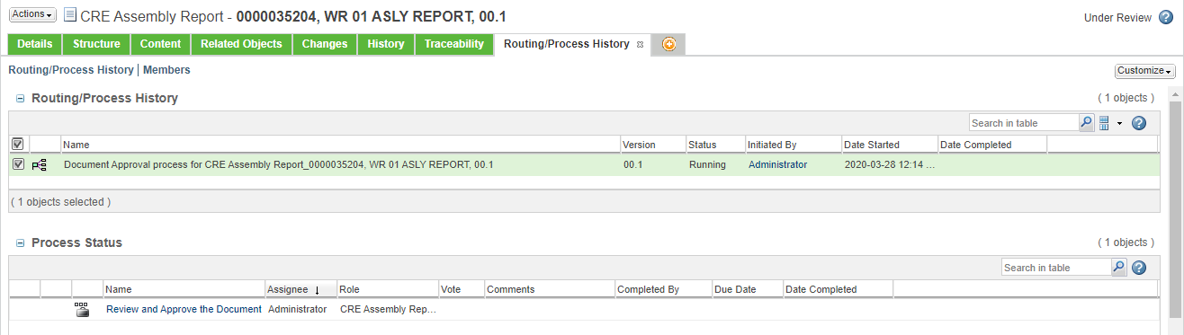
- On approval document state changes & it gets attached to respective Work Request.
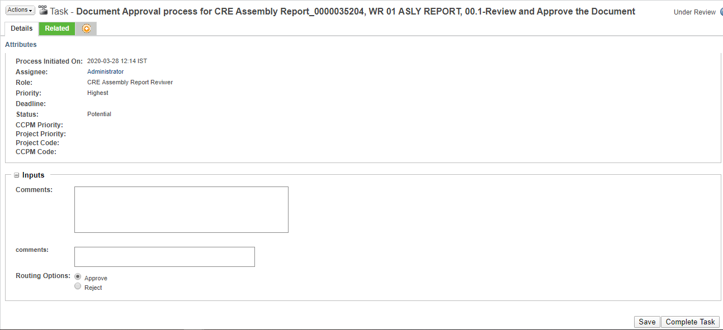

CRE Test Report Creation & Approval Process:
- Report can be created by going to browse tab then go to Libraries the go to CRE Reports library and then in the Folders or through the link given on task page.
Click Browse Tab Libraries CRE Reports Folders



- In folders go to CRE Test Reports folder
Folders CRE Test Reports
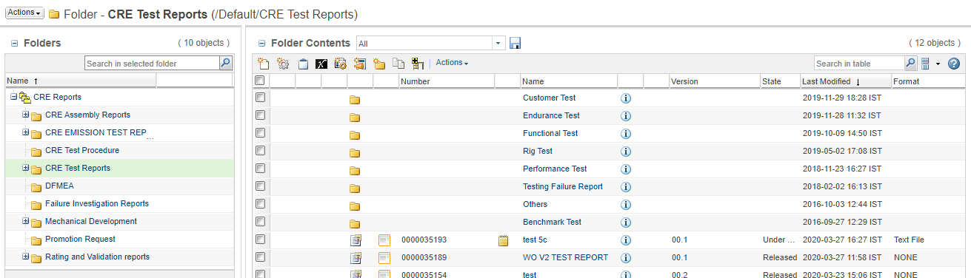

- Now click on the new document to create new CRE Test report.


- Select type CRE Test Report from select type.
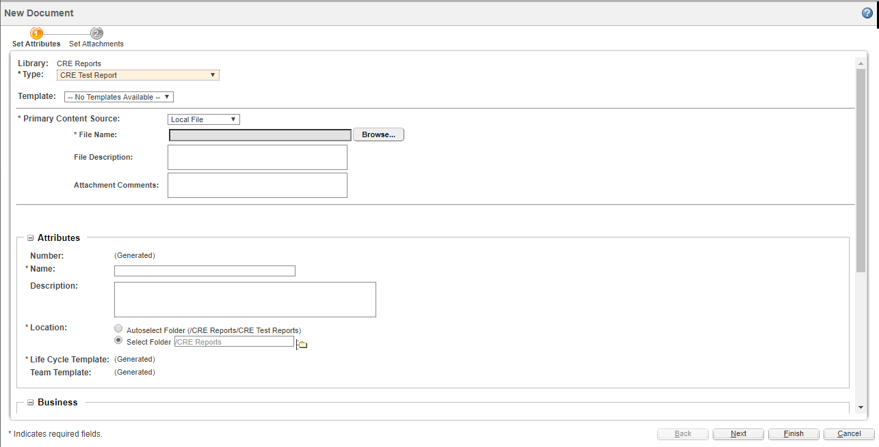
- Attach source file to CRE assembly report through browse button.


- Fill all the mandatory fields and click on finish.
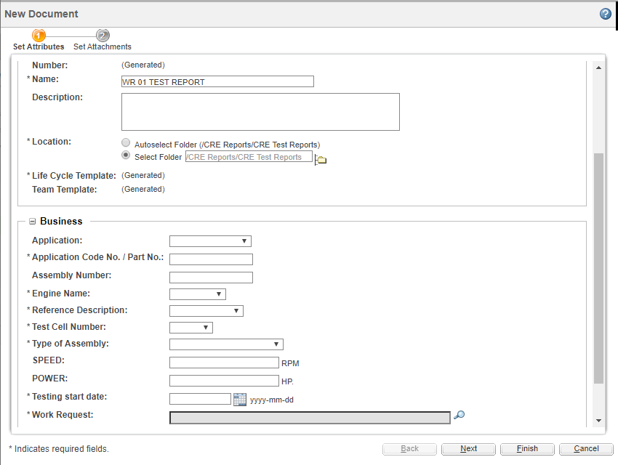



- On creation of the document approval task is assigned to CRE Report Approver. Approver can Approve / Rework document for changes.
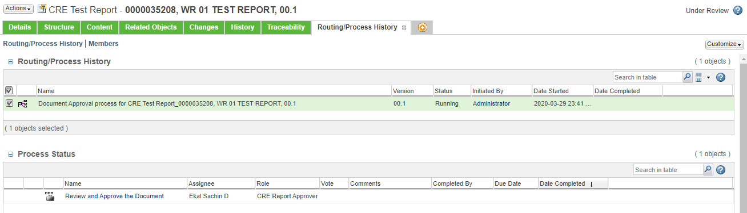
- On approval document state changes & it gets attached to respective Work Request.
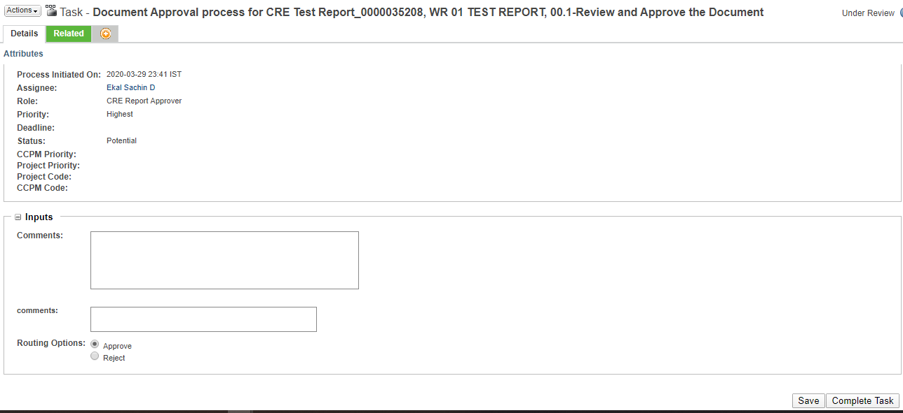

Emission Test Report Creation and Approval Process:

- Go to browse tab then go to Libraries the go to CRE Reports library and then in the Folders.
Click Browse Tab Libraries CRE Reports Folders



- In folders go to CRE EMISSION TEST REPORT folder then go to Teardown Reports
Folders CRE Reports CRE EMISSION TEST REPORT New Document

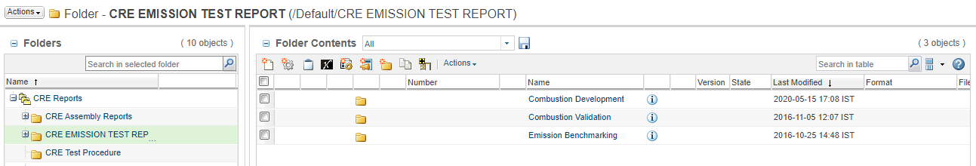

- Select Emission Test Report from select type & attach source file to Emission Test report through browse button.

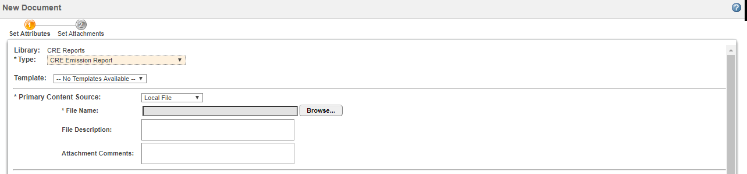

- Fill all the mandatory fields and click finish.
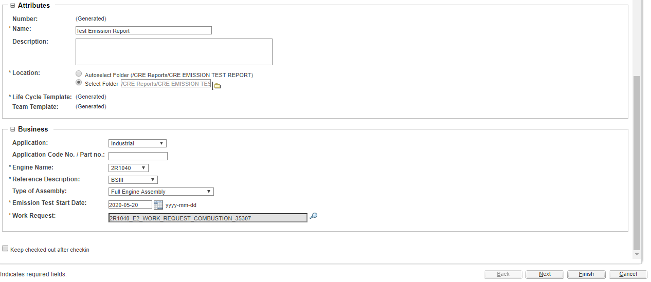



- On creation of the document approval task is assigned to Emission Test Report Reviewer. Approver can Approve / Rework document for changes.
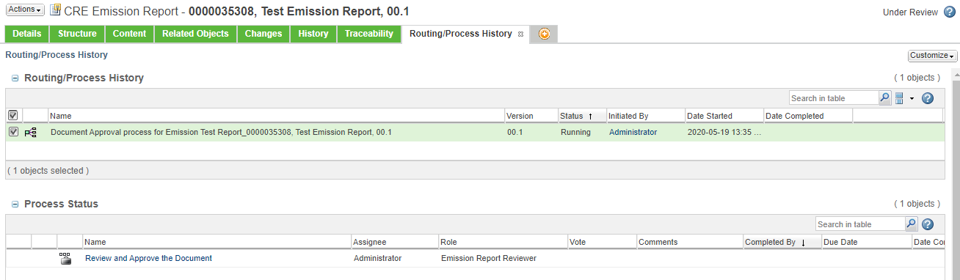

- On approval document state changes & it gets attached to respective Work Request.

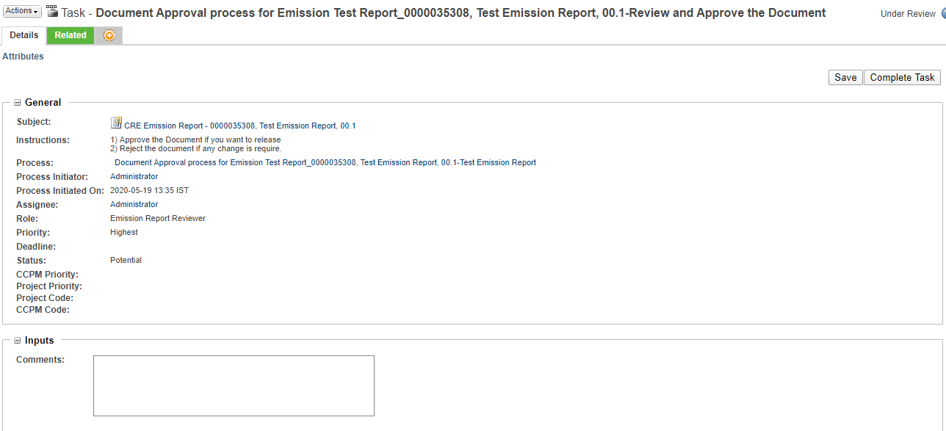

Swirl Lab Test Report Creation & Approval:

- Report can be created by going to browse tab then go to Libraries the go to CRE Reports library and then in the Folders or through the link given on task page.
Click Browse Tab Libraries CRE Reports Folders



- In folders go to Swirl Lab Testing Reports folder
Folders Swirl Lab Testing Reports Create new document

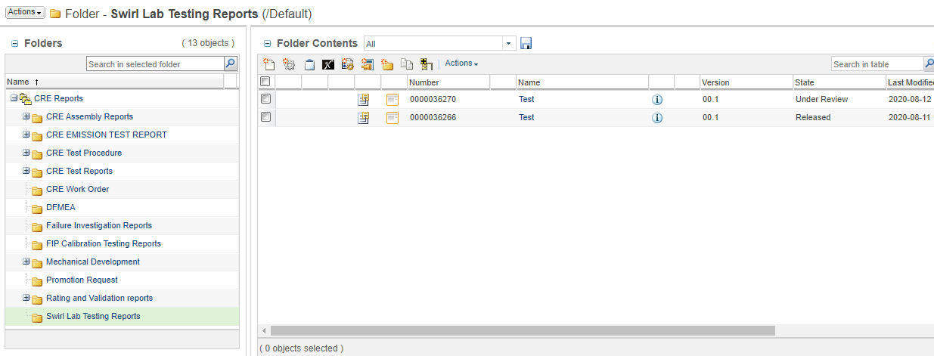

- Select type Swirl Lab Testing Reports from select type.

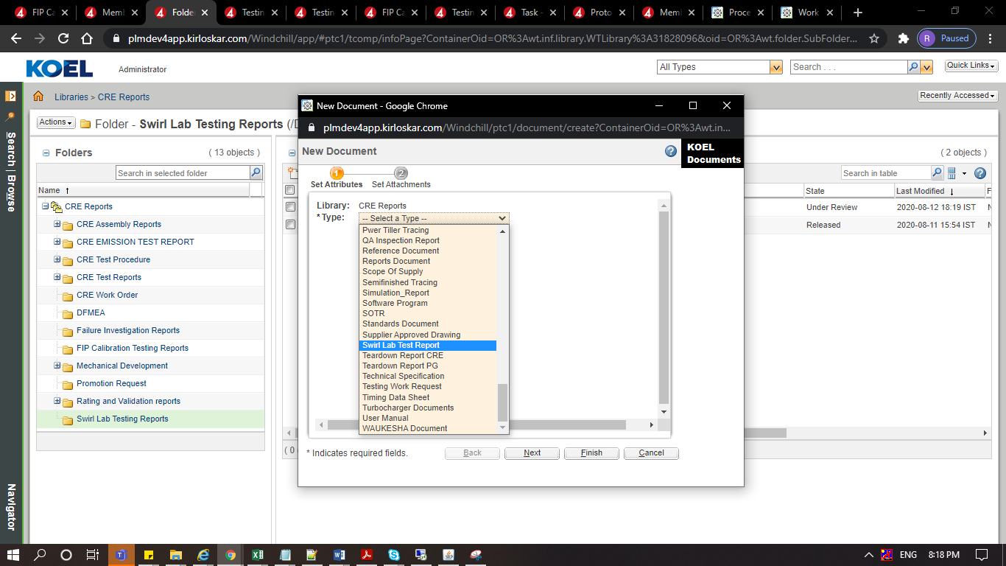

- Attach source file to CRE assembly report through browse button.
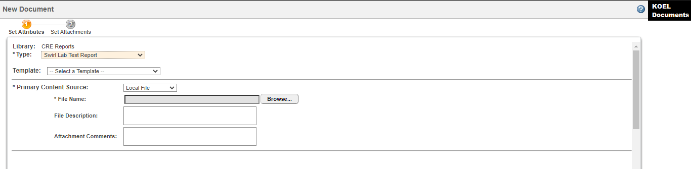

- Fill all the mandatory fields and click on finish.

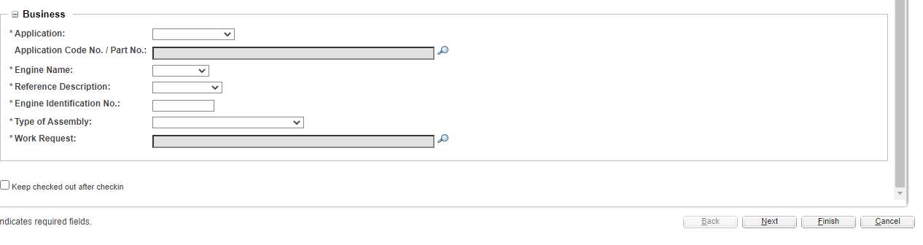

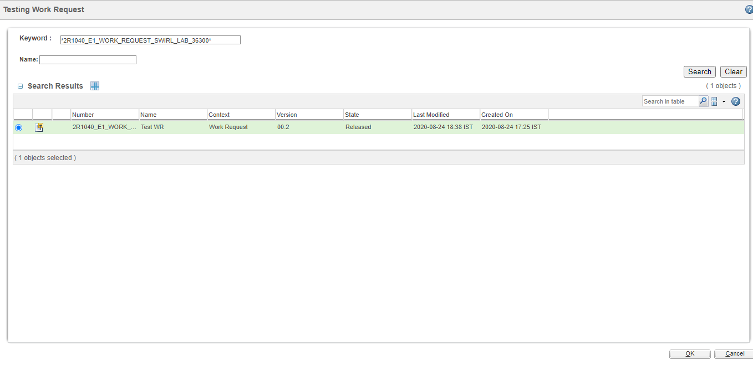

- On creation of the document approval task is assigned to Combustion HHP Head / Combustion LHP & MHP Head depending on the group in which document creator belongs to Combustion HHP group or Combustion LHP & MHP group. Approver can Approve / Rework document for changes.

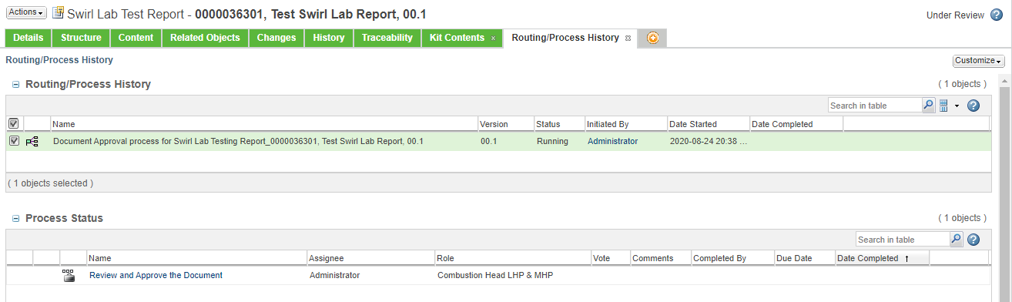

- On approval document state changes & it gets attached to respective Work Request.

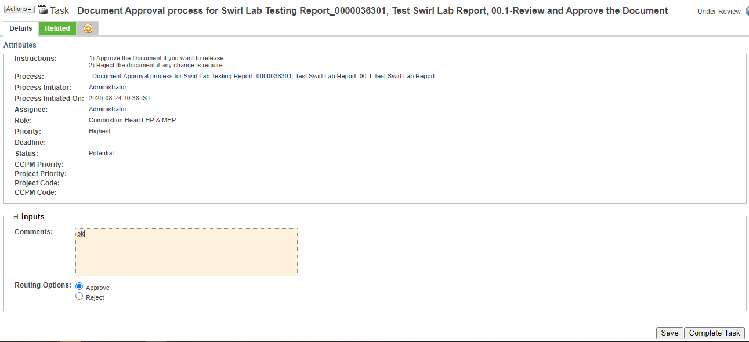



FIP Calibration Test Report Creation & Approval Process:

- Report can be created by going to browse tab then go to Libraries the go to CRE Reports library and then in the Folders or through the link given on task page.
Click Browse Tab Libraries CRE Reports Folders



- In folders go to FIP Calibration Testing Reports folder
Folders FIP Calibration Testing Reports

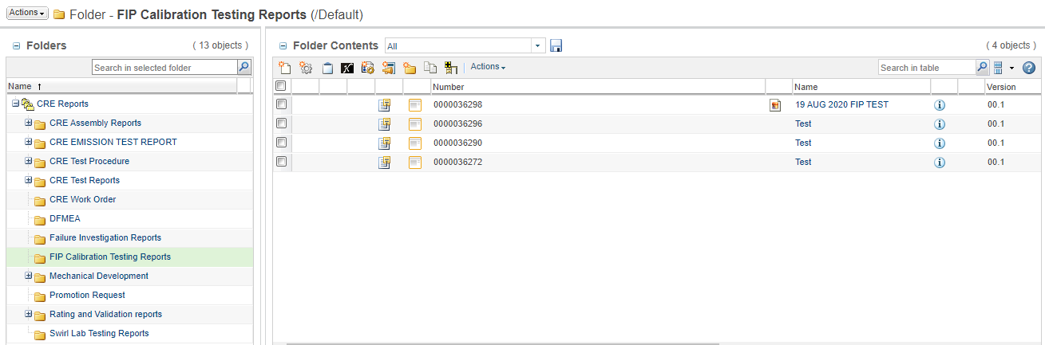

- Now click on the new document to create new FIP Calibration Testing Reports report.



- Select type FIP Calibration Testing Report from select type.
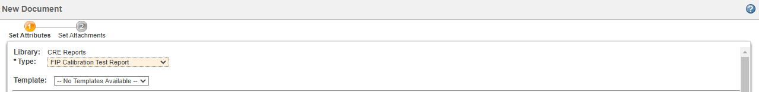
- Attach source file to FIP Calibration Testing Report through browse button.
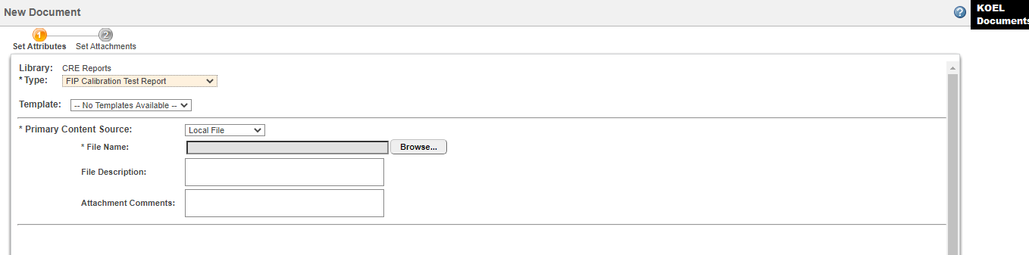

- Fill all the mandatory fields and click on finish.




- On creation of the document approval task is assigned to Combustion HHP Head / Combustion LHP & MHP Head depending on the group in which document creator belongs to Combustion HHP group or Combustion LHP & MHP group. Approver can Approve / Rework document for changes.
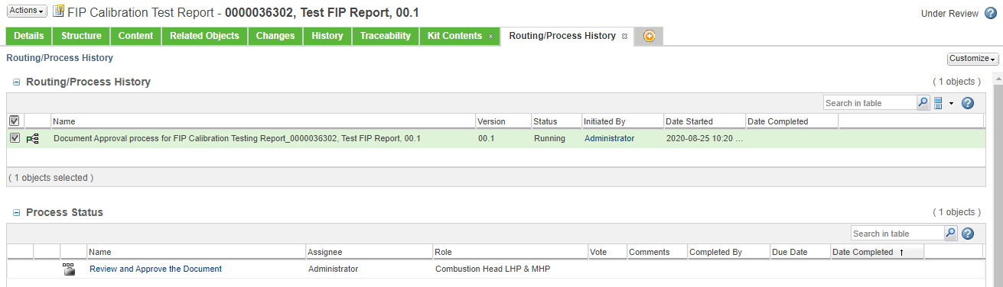

- On approval document state changes & it gets attached to respective Work Request.

